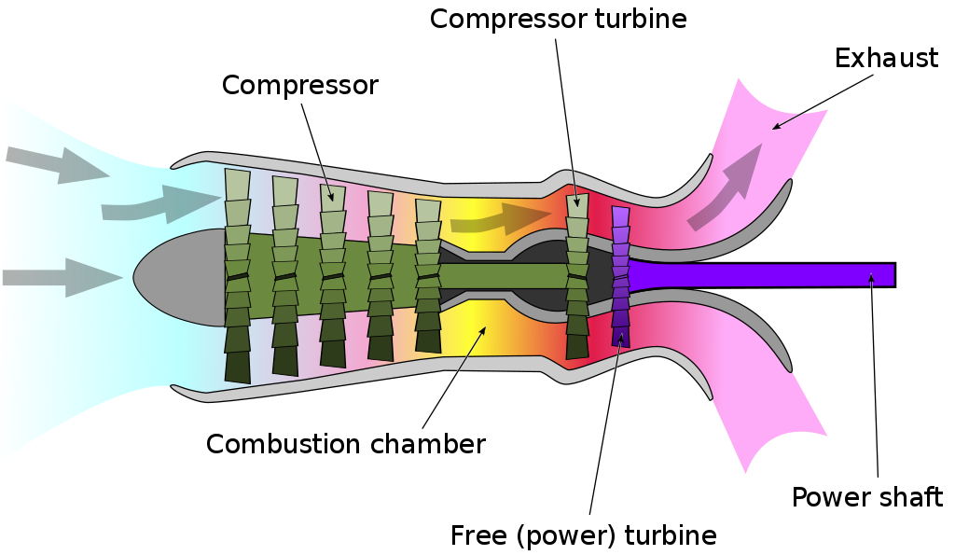Turboshaft Engine:

A **turboshaft** engine is a form of [gas turbine](https://en.wikipedia.org/wiki/Gas_turbine) that is optimized to produce shaft [power](https://en.wikipedia.org/wiki/Power_(physics)) rather than [jet thrust](https://en.wikipedia.org/wiki/Jet_thrust).

Application:

[helicopters](https://en.wikipedia.org/wiki/Helicopter), [auxiliary power units](https://en.wikipedia.org/wiki/Auxiliary_power_unit), [boats](https://en.wikipedia.org/wiki/Boat) and [ships](https://en.wikipedia.org/wiki/Ship), [tanks](https://en.wikipedia.org/wiki/Tank), [hovercraft](https://en.wikipedia.org/wiki/Hovercraft), and stationary equipment.

An **auxiliary power unit** (**APU**) is a device on a [vehicle](https://en.wikipedia.org/wiki/Vehicle) that provides energy for functions other than [propulsion](https://en.wikipedia.org/wiki/Propulsion).

Turboprop in Nepal:

Buddha Airlines uses:

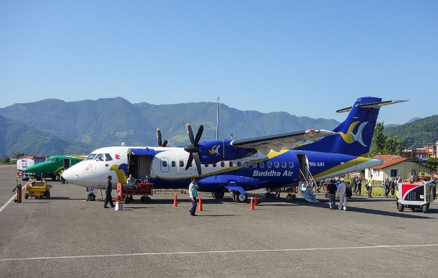

ATR 42-300….Passenger 47

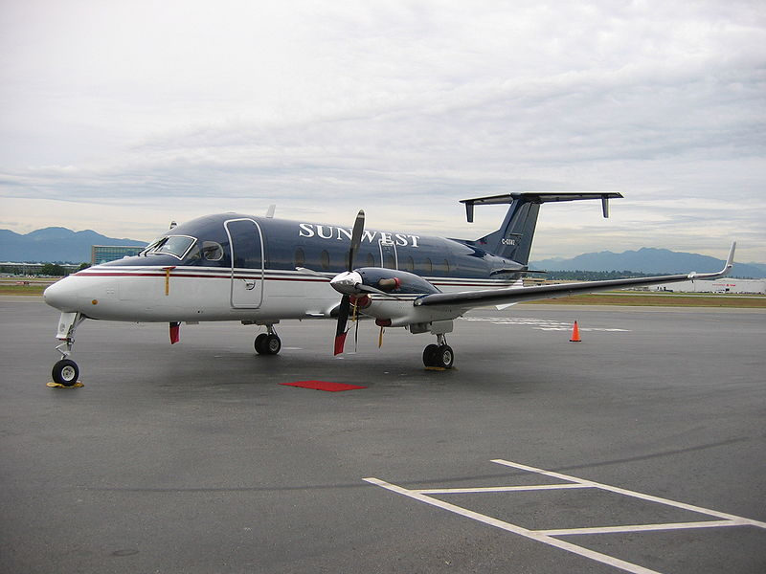

Beechcraft……..Passengers 18

Nepal Airlines (also known as RNA-Royal Nepal Airlines NAC)

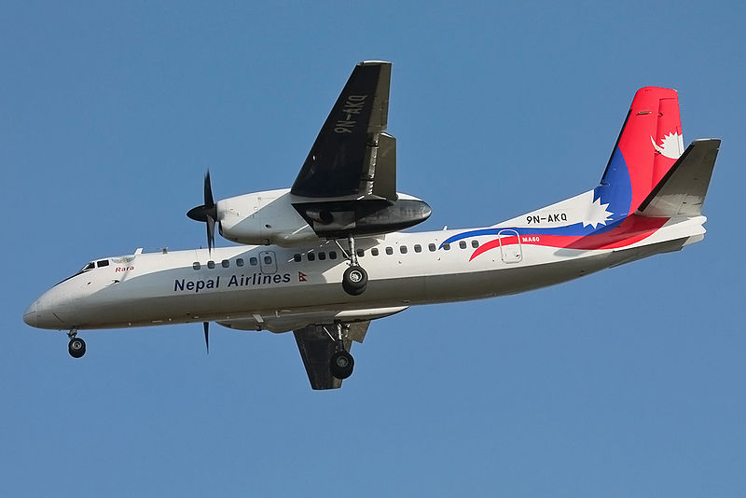

[Xian MA-60](https://en.wikipedia.org/wiki/Xian_MA-60): Passenger 56

Compressor Stall:

A compressor stall occurs when there is an imbalance between the air flow supply and the airflow demand.

Blade Twisted:

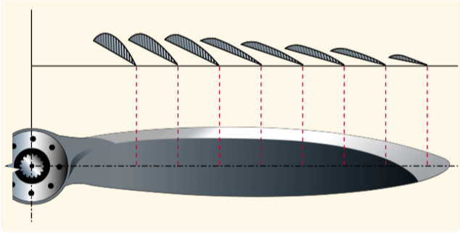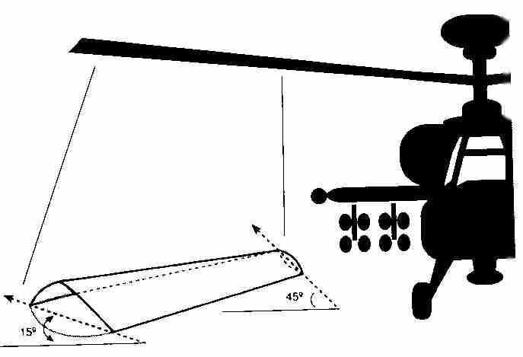

Most of the helicopter rotor blades are also twisted like the propeller blades of airplanes. The twist on the blades is made such that the angle of attack at the tips once it starts moving is lower than at the root. As the tip of the props and rotor blades move faster in the air than the root, the tips tends to create more lift. Thus, the aerodynamic loads experienced by the tips is a lot more than that experienced at the root. This can damage and can even snap off the blades from the tips in flight.

The lowering of angle of attack at the tips reduce the lift created at the tips in such a way, that it equalises the lift generated at the root. The result is a uniform lift production along the length of the blades increasing the life span of the blades and decreasing the chance of an in flight breakup.

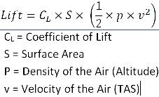

Multi-staging needed in turbine?

A one staged turbine would mean that the steam has to be expanded greatly in a very short distance. This would lead to great aerodynamic losses and/or not all available energy can be extracted from the steam. The strength of blade must be high enough to withstand the stress developed by pressure gradient.

The highest-pressure steam enters the first smallest diameter turbine the reduced pressure steam is then passed through a larger diameter turbine and finally the process is repeated through the largest diameter turbine before the steam is passed into a condenser.

The engineering challenge is both to design the turbines so they operate at a synchronous speed. For this the blades of turbine also goes on increasing.

For high-power output and high efficiency. To achieve this, an axial turbine with multiple stages is required. To achieve this, the axial velocity and the mean blade radius must remain constant throughout the turbine. To allow for the reduction in fluid density that arises as the flow expands through the turbine, the blade height must be continuously increasing between blade rows. Figure 4.5 shows the arrangement of a multistage turbine within an aeroengine showing the increasing blade height and the constant mean radius.

For the velocity diagrams to be the same, the flow angles at exit from each stage must be equal to those at the inlet. The requirements for a repeating stage can therefore be summarized as

[image](http://lh3.googleusercontent.com/-ZvgBccG8cxE/VWPBizzwtxI/AAAAAAAAIc0/ctwBHxsv4rg/s1600-h/image5.png)

